RECENT ESTIMATES OF THE IMPACT OF THE ACA ON INSURANCE COVERAGE

CHRISTINA J. MURRAY

UNIVERSITY OF NOTRE DAME

December 19, 2019

**Introduction:**

This investigation explores whether estimates of the impact of the ACA on insurance coverage are different depending on the use of an initial year dataset (2012-2014) or a full year dataset (2012-2017). As firms and states acclimate to the ACA’s implementation, the data should predict a likelihood of coverage that is larger for 2012-2017 than for 2012-2014. After determining a causal estimate of the ACA’s impact, this study will address how workers of different socioeconomic statuses were affected by the expansion of the ACA. The estimates should show that low-income earners are less likely to be covered by their employer and more likely to have Medicaid.

Based on 2016 estimates, about 20 million adults gained coverage after the implementation of the ACA (Serakos and Wolfe, 2016). Before it was implemented, coverage laws varied across states, and the median state only offered Medicaid coverage to working parents with incomes under 64% of the Federal Poverty Line (FPL) (Garrett, 2017). Additionally, in most states, workers without dependent children were not offered Medicaid, regardless of their income level. In order to increase healthcare coverage of the target low income population, the ACA expanded Medicaid eligibility to those with incomes up to 138% above FPL. Additionally, those with incomes 139% to 400% above FPL could apply for health insurance subsidies. In 2012, Congress determined that penalizing states who refused to expand Medicaid was unconstitutional. Therefore, by 2014, some states had implemented the expansion while others had not. This is an important source of exogenous variation, which has been exploited by many economists through difference-in-differences (DD) models to quantify the ACA’s causal impact on insurance coverage rates.

Williamson et al. provide illuminating descriptive statistics on the relationship between socioeconomic status and health insurance (Williamson, 2016). They find that low-income workers, specifically those in the agriculture and service industries, are less likely to have employer sponsored insurance and are more likely to be uninsured. The article provides correlative estimates of gains in coverage for low-income workers from 2013-2014 as a result of the ACA. Figure 1 emphasizes that low-income workers are more likely to be covered by Medicaid and less likely to be covered by their employer.

This study will estimate simple DD models as well as a triple difference (DDD) model to determine the causative impact of the Medicaid expansion on different types of insurance for the full set of years 2012-2017. Socioeconomic status controls for income and occupation are included, and they estimate the likelihood that these groups have specific types of insurance. These models will provide causal estimates of the impact of the ACA on insurance coverage, and it will determine whether the ACA continues to impact the correct demographics. Under the current political administration, changes have been made to the ACA, such as the elimination of the individual mandate, which guards against adverse selection in the markets. With continuing changes in the political sphere concerning the ACA, it is important to accurately determine whether the ACA was effective, and which groups are most vulnerable to changes in healthcare policy.

The simple DD model estimates for years 2012-2017 that the Medicaid expansion increased the probability of having any insurance by 1.6%, compared to 1.4% in 2012-2014. The triple difference model also estimates that the Medicaid expansion increased the probability of any insurance by 1.6% for the full year dataset. Its estimate for 2012-2014 is slightly lower, at 1.1%. Additionally, the data was divided into groups above and below the median uninsured rate, and additional DD estimates on each group show that the Medicaid expansion increased the probability of having any insurance by 2.15 more percentage points in expansion states below the median uninsured rate. Despite this significant variation, the similarity between the DD and DDD estimates shows that the simple DD model is sufficient to estimate the impact of the ACA on having any insurance, and the variation caused by differences in uninsured rates is not as important as the literature posits. Middle coverage jobs are more likely to have Medicaid, and the estimates verify that low and middle coverage occupations are still less likely to have insurance even with the ACA in place. The simple DD models and occupation dummy variables indicate that the ACA negatively affected employer provided insurance, while the DDD model estimates the opposite.

**Literature Review:**

A variety of studies have already been performed on the initial impacts of the ACA, and they differ in the demographics of the individuals they study and the degree to which they estimate a causal impact of the ACA on coverage. Kominski et al. summarize the results of studies on the initial impacts of the ACA on low-income populations (Kominski, 2017). Many studies have already shown that the ACA increased rates substantially among those demographics who traditionally lack coverage: low-income adults, ethnic minorities, childless adults, and young adults. They also emphasize the well-known effect that those in Medicaid expansion states have experienced larger coverage increases than those in non-expansion states. Low-income adults living in these non-expansion states fall into a “coverage gap,” because their income may be above the state’s Medicaid eligibility threshold but below the 100% threshold for subsidy eligibility. Therefore, as of 2016, 32 million people remain uninsured in the US, and 27% of them are eligible for Medicaid, so the ACA’s impact has not been fully realized.

In a 2016 summary of ACA impacts on health, access, and employment, authors Serakos and Wolfe compile preliminary results from studies of the ACA’s impact on the general population and young adults (Serakos and Wolfe, 2016). The most interesting studies use a DD estimation to form control and treatment groups and thus obtain more significant estimates of the ACA’s effect on coverage. Gooptu et al. estimates a DD model on CPS data from 2005-2014 to show that the Medicaid expansion did not affect job turnover or wages for the general population. Many authors estimate DD models on the young adult population and find higher increases in coverage for 19-25 year olds than older populations. However, all of these studies use time periods that do not go beyond 2012. Because of their use of very specific populations and time periods, there is room for improved estimations using broader populations and more current years.

Based on the summaries by Kominski and Serakos, a study that focuses on low-income groups and includes data from more recent years would be additive to the current literature. Additionally, recent studies by Garrett et al. and Williamson et al. display a need for analysis using more complex models, like a DD estimate. Garrett et al.’s 2017 study divides workers based on occupation and uses ACS and CPS data from 2010-2015 to show that coverage gains tend to be higher for workers with lower coverage occupations (Garrett, 2017). They estimate that 6.02 million workers gained coverage in expansion states, while 3.51 million workers, a considerable lower number, gained coverage in non-expansion states. To account for other factors that may have affected workers’ coverage status and wages, such as macroeconomic effects or decreased labor supply, the authors compare the 2015 estimates with a 2010 counterfactual that is adjusted to reflect the demographic and occupation composition in 2015. They conclude that their estimates are valid because the difference between the 2015 estimates and the 2010 counterfactual are small. However, a DD model would have been more effective in isolating the Medicaid expansion effect.

Similarly to Garrett, Williamson et. al. also estimate a large increase in coverage due to the Medicaid expansion. They estimate that from 2013 to 2014, the number of low-income workers with Medicaid increased from 18 to 23%, and the amount of uninsured low-income workers dropped from 35% to 26% (Williamson, 2016). They note the presence of between state variation, stating that low-income workers in expansion states are more likely to have coverage due to the ACA. Due to the state and year variation, these findings include the preliminary necessities for a DD model. However, the authors do not estimate one and simply supply these raw estimates for change in coverage.

In their 2017 paper, Courtmanche et al. use a DD specification as well as a DDD model to estimate the impacts of the ACA on coverage rates for 2011-2014 (Courtmanche, 2017). Using the simple DD, they estimate that the full ACA increased the probability of having any insurance by 3.7 percentage points. Due to concerns about exogeneity and parallel trends, the authors also estimate a DDD model based on 2013 pre-treatment uninsured rates. They structure their uninsured rate model after the DD specification used in Miller’s 2012 study on the effect of the Massachusetts health reform on emergency room visits. Miller interacts year fixed effects with 2005 uninsured rates to show that the reform reduced total ER visits (Miller, 2012). This model is based on the assumption that counties with higher initial uninsured rates would have a higher increase in coverage. They also assume parallel trends, specifically that if the reform had not occurred, emergency room usage in high and low uninsured counties would have evolved similarly. Courtmanche mimics this study to reach a similar conclusion about parallel trends for their model; if the ACA had not occurred, the trends in expansion and non-expansion states, as well as in high and low uninsured areas, would have evolved similarly. Courtmanche et al. complete extensive robustness checks to argue the exogeneity of their model, and they find that the full ACA increased the probability of having any insurance by 5.9 percentage points. The authors also determine that the effects of the Medicaid expansion on private coverage, employer-sponsored insurance (ESI), and individually purchased insurance are small and not statistically significant.

The following study estimates a simple DD model as well as a DDD model using uninsured rates to compare early year estimates to full year estimates. These models expand on Courtmanche’s study not only by expanding the range of years in the dataset, but they also focus on occupation and income controls. Additionally, simple DD models are also performed on data subsets that are above and below the median uninsured rates to generate coefficients that can be more easily interpreted than those in the DDD model. This is done to address the broad assumption that expansion and uninsured state status trends would be the same in the counterfactual reality of no ACA.

**Data:**

The dataset that will be used in this study is an extract from the American Community Survey (ACS). Two million households are randomly selected annually to complete the survey. This cross-sectional data is one of the most common sources of health insurance coverage data, but it does not follow individuals longitudinally. In this study, regressions run on full year data are compared with regressions run only on initial year data. The full year dataset contains 11,452,979 observations, and the initial year dataset contains 5,722,416 observations.

Table 1 contains descriptions of the variables that are included in this dataset. The part of the data that is particularly useful are individuals’ reports on whether they have different types of health insurance. This study focuses on dependent variables that indicate any health insurance (HI), private HI, employer-provided HI, directly purchased HI, and Medicaid. Based on reports by the Kaiser Family Foundation, 25 states expanded Medicaid in 2014 and 25 states did not. The variation in state expansion status sets up a DD model quite nicely; non-expansion states can be used as the control group, and the expansion states are the treatment group. The variable *expand* indicates whether states expanded Medicaid in 2014, and the variable  *y14* indicates the year.

This investigation will also estimate a triple differences model that exploits variation in the 2013 pre-treatment uninsured rate (*unsp*) across areas. In the dataset, housing units are located in Public Use Microdata Areas (PUMA) that are reported in combination with the house’s statefip location. These areas tend to follow single counties or county groups, and they do not exceed 200,000 residents. Using these areas, the 2013 pre-treatment uninsured rate was determined to be 0.183. Unfortunately, Courtmanche et al. do not use the PUMAs to construct their estimates of pre-treatment uninsured rates, because the PUMA boundaries are redrawn every 10 years. Therefore, the 2010 and 2011 respondents correspond to the Census 2000 based PUMAs, while respondents from 2012 and later correspond to the Census 2012 based PUMAs. Because Courtmanche et al. estimated their model in the early years of the ACA (2011-2014), they could not rely on the PUMAs and defined areas based on core-based statistical areas, which are made up of at most 50,000 individuals. Therefore, the estimates in this paper are not directly comparable with Courtmanche’s estimates due to the definition of these areas.

A variety of control variables are also included in Table 1. The most relevant of these are *age*, *poverty*, and *covclass*. Ages younger than 18 years are not included, due to children’s access to health insurance under their parents, and ages 65 and above are dropped due to Medicare. *Poverty* indicates how high the individual’s income is above the poverty level, and this variable is an indicator for three different buckets of poverty states: low (0-138%], middle (138-400%], and high (400%-501%]. Since the Medicaid expansion is based on an individual’s poverty status, this variable is very important in capturing whether the expansion targeted the correct individuals. Additionally, the variable *covclass* is crucial to answering how employees were affected by the expansion. It is based on the IPUMS variable *occ*, which defines an individual’s occupation, and it divides the dataset into four occupational groups: *covlow*, *covmid*, *covupmid,* and *covhigh*, which are based on Garrett et al’s division of occupations into <70% coverage, 70-79% coverage, 80-89% coverage, and 90-100% coverage, respectively. Table 2 displays which occupations fall under which coverage classes.

Figures 2, 3, and 4 summarize key descriptive statistics for the dataset. Figure 2 displays mean coverage rates for Medicaid and individually purchased insurance, which had the greatest variation due to state expansion status. Figure 3 includes mean coverage rates for the other types of insurance by expansion and uninsured rate statuses. These bar graphs are a key visual presentation of the heterogeneity that is exploited in the DDD model, which is introduced and discussed further in the Results section. Although the magnitude of the differences vary, for all types of insurance, there is a difference in coverage between expansion and non-expansion states and between states above and below the median uninsured rate. Whether this variation is significant is a central focus of the DDD specification. Figure 4 shows the mean coverage rates for different types of insurance by occupation type. From this figure, it is evident that those with low and mid coverage jobs in non-expansion states are less likely to have Medicaid than those in expansion states. Low and mid coverage jobs are also more likely to have any type of insurance in expansion versus non-expansion states. For high coverage, and subsequently high income jobs, it is immediately evident that they have greater access to employer provided and private insurance. The variation that is present in this figure is explored in greater detail via controls in the econometric specifications.

**Results:**

The simple DD model used in this investigation is described by equation 1 below:

[1]

where is an indicator variable for whether the individual *i* at time *t* in state *s* has a specific type of insurance. The variable is an indicator for whether the year is post 2014, the ACA’s Medicaid expansion year, and is an indicator for whether the state expanded Medicaid in 2014. *X* is a vector containing various demographic, family, and income controls that were determined via various robustness checks, which are described later in this investigation.

From this simple DD model, rough estimates of the effect of the ACA on insurance coverage were determined. Table 3 includes these estimates for the initial and full year datasets. Courtmanche et al.’s simple DD model estimate is also included as a point of comparison. The initial year DD model estimates that the non-Medicaid components of the ACA increased , the probability of having any insurance, by 2.8%, which is the same as Courtmanche’s estimate. The Medicaid components of the ACA, increased the probability of having any insurance by 1.4%, which is larger than Courtmanche’s estimate of 0.90%. Running this model on the full set of years increased the estimates to 4.9% for non-Medicaid components and 1.6% for Medicaid components. This increase was expected, considering that the additional 3 years in the dataset allowed the ACA expansion to continue to solidify in states that decided to expand.

In order to assume that is causal, the assumption of parallel trends must be true. Specifically, if ACA expansion had not occurred, both non-expansion and expansion states would continue to follow the same trend as before the expansion. Courtmanche addressed the assumption of parallel trends via Figure 1 in their paper, and stated that visually the trends for expansion and non-expansion groups look similar. In Figure 5, I also show that these trends are parallel across income groups. However, in order to address this assumption further, Courtmanche uses local area pre-treatment (2013) uninsured rates. To support the use of uninsured rate variation in the model, Figures 2 and 3 show that there is a visible difference in the change in coverage rates in areas above and below the 2013 median uninsured rate.

The intensity of the change in coverage rates due to pre-treatment uninsured rates can be quantified by dividing the data into groups that are above and below the median uninsured rate and by performing the simple DD regression on these groups. In areas subject to the expansion that were above the median uninsured rate, the expansion increased the probability of having any insurance by 3.35% in comparison to 0.55% in states below the median uninsured rate (Table 4). This estimation supports the idea that coverage intensity varies based on uninsured rates, because areas with a larger uninsured population has more individuals gaining coverage as a result of the ACA. Another interesting estimation from this comparison is that the and coefficients are negative for employer sponsored insurance in areas below the median uninsured rate, which suggests that the ACA caused employer sponsored insurance to decrease.

Since the estimates in Table 4 show that the Medicaid expansion affected coverage rates differently depending on an area’s uninsured rate, there is substantial heterogeneity of effects that can be exploited in a triple difference (DDD) model. This model is described by equation 2,

[2]

where , , , and are the same as in the DD specification, and is the 2013 pre-treatment uninsured rate for area *a* in state *s*, determined using the PUMAs described in the data section above.multiplied by the median uninsured rate of 0.183 estimates the impact of the non-Medicaid components of the ACA, while times the median uninsured rate estimates the impact of the Medicaid expansion. These estimates are summarized in Tables 5 and 6, and they include the Courtmanche’s estimates as a point of comparison. Courtmanche’s 2011-2014 estimates for tend to be lower and tend to be higher compared to my estimates for the years 2012-2014. These differences can be attributed to Courtmanche’s use of CBSA’s rather than the PUMA’s, which cause them to have uninsured rate estimates that are different. Understandably, the estimates in Table 6 for years 2012-2017 have larger coefficients than those for years 2012-2014 in Table 5. For the initial years, the states who expanded Medicaid had an average increase in any insurance by 1.1%, versus 1.6% for all years. Both the DD and the DDD specification for all years estimate that the expansion increased any insurance by 1.6%; therefore, the simple DD captures the impact quite well, and the importance of uninsured rates may be overstated in the literature. The probability of having employer sponsored insurance also increased as a result of the Medicaid expansion from 0.47% in the initial years to 0.62% in all years, which goes against the implications of crowd out from Table 4, which estimated negative coefficients for areas below the median uninsured rate. Finally, the probability of having Medicaid expectedly increased from 0.6% in the initial years to 1.9% using all years.

To address the impact of the ACA on workers, income and occupation controls were included. Tables 9-13 in the Appendix include robustness checks for demographic, family, and income controls. For all insurance cases except employer provided insurance, using all types of controls increased the R squared significantly and did not cause standard errors to increase substantially. Therefore, including these controls accounts for bias that is present in the model without them. For estimates on employer provided insurance, only income controls were included, because using all controls decreased the R squared substantially. Without these controls, estimates have an upward bias for all estimates except Medicaid, which suggests that much of the variation can be explained by these control variables. For Medicaid, coefficients are underestimated, because variables like income are negatively correlated with Medicaid rates.

Tables 7 and 8 summarize the estimates of the impact of socioeconomic status controls on types of insurance for the initial and full year datasets. Compared to a high coverage job, having a low coverage job decreases the probability of having any insurance by 12.7% and increases the probability of Medicaid coverage by 2.6%. Having a middle coverage job increases the likelihood of having Medicaid by 6%, which is more than twice the magnitude of low coverage jobs. Additionally, this likelihood is 0.4% greater than the initial year estimation. These results indicate that the Medicaid expansion targeted the correct area of the workforce. Since the Medicaid expansion extended Medicaid to those with incomes 138% above the poverty line, and targeted single working adults, it makes sense that middle coverage jobs would experience the greatest increase in Medicaid coverage, since low-coverage jobs would already have been covered by Medicaid. These estimates also illustrate the importance of employer provided insurance in the US healthcare system. Having a high income compared to a low one increases the probability of ESI by 44.7%, and low coverage jobs are 15.4% less likely to have ESI. Mid and low coverage jobs are also less likely to have insurance in general. Finally, for middle and high incomes, they are slightly less likely to have ESI in the full year dataset compared to the initial years, which could indicate crowd out.

**Conclusion:**

The econometric models in this study explored various ways to estimate the impact of the ACA, and discuss the assumptions that must be made when determining the causal effect of a policy. A simple DD model estimated that the Medicaid expansion increased any insurance coverage by 1.4% in the initial years and 1.6% in the full years. The triple difference estimates were a 1.1% increase to the initial years and 1.6% for the full years. Therefore, because the Medicaid expansion increased insurance coverage by 1.6% in both the DD and DDD specifications for 2012-2017, the question arises as to whether the uninsured rate should be included when estimating the ACA’s impact. To assess the importance of the uninsured rate, I would like to run the simple DD model on all insurance types to see how they vary from the DDD model. Since many issues arise from controlling for both expansion status and uninsured rates, if the DDD is unnecessary, it is much easier to run a simple DD specification when analyzing a policy implementation. The DD model estimated that the full ACA impact in 2012-2014 was 3.2 percentage points, and the estimate for 2012-2017 was 5.1 percentage points. These estimates can be compared to Courtmanche’s estimate of 5.9 percentage points.

Overall, this study analyzed a time period of data that has not yet been explored in the literature. By comparing these time periods using different specifications, some interesting estimates arose that I would like to explore further. Specifically, the ACA’s impact on ESI was uncertain. The socioeconomic control estimates and the DD estimates in areas below the median uninsured rate indicated crown out. Considering that areas with low uninsured rate probably have populations with high employment and high coverage, this could indicate that firms are choosing to pay the penalty and forgo providing insurance. However, crowd out was not implied by the DDD specification, so more research needs to be completed to reach a significant conclusion.

This study improved the understanding of how workers of specific occupations are affected by healthcare policy changes, but I would also like to explore how the different types of firms that employ these individuals reacted to the ACA. A dataset that follows individuals longitudinally and includes insurance premium prices as well as more details on insurance plans could be useful. I would like to see how individual employment status changes and how their insurance coverage changes as a result. I could also estimate other models such as a heterogeneous logit, to analyze consumer tastes for health plan features and consumers decisions between plans. Additionally, changes to the ACA have recently begun to be implemented under the current administration. It would be interesting to see how individuals and firms react to this. Because there are such drastic differences between occupational coverage rates, it is crucial to assess healthcare policy, so that legislation can effectively improve individuals’ healthcare access within the heterogeneous landscape of the US healthcare system.

Works Cited

Courtemanche, James Marton, Benjamin Ukert, Aaron Yelowitz, and Daniela Zapata. 2017.

[“Early Impacts of the Affordable Care Act on Health Insurance Coverage in Medicaid](https://www3.nd.edu/~wevans1/class_papers/Courtemanche_et_al_JAPPAM.pdf)

[Expansion and non-Expansion States.”](https://www3.nd.edu/~wevans1/class_papers/Courtemanche_et_al_JAPPAM.pdf) *Journal of Policy Analysis and Management* 36(1): 178-210

Garrett B, Gangopadhyaya A, Dorn S. Workers Gaining Health Insurance Coverage

under the ACA. Washington: Urban Institute; 2017. <https://www.urban.org/research/>

publication/workers-gaining-health-insurance-coverage-under-aca.

Gooptu Angshuman, Moriya Asako S., Simon Kosali I. and Sommers Bejnamin D. (2016)

“Medicaid Expansion Did Not Result in Significant Employment Changes Or Job

Reductions in 2014,” Health Affairs 35(1):111–118.

Kominski, Gerald F et al. “The Affordable Care Act's Impacts on Access to Insurance and Health

Care for Low-Income Populations.” *Annual review of public health* vol. 38 (2017):

489-505. doi:10.1146/annurev-publhealth-031816-044555

Miller, S. (2012). The effect of insurance on emergency room visits: An analysis of the 2006

Massachusetts health reform. Journal of Public Economics, 96, 893–908.

Serakos, Maria, and Barbara Wolfe. “The ACA: Impacts on Health, Access, and Employment.”

*Forum for health economics & policy* vol. 19,2 (2016): 201-259.

doi:10.1515/fhep-2015-0027.

Williamson A, Antonisse L, Tolbert J, Garfield R, and Anthony Damico. ACA Coverage

Expansions and Low-Income Workers. Kaiser Family Foundation; 2016.

https://www.kff.org/medicaid/issue-brief/aca-coverage-expansions-and-low-income-workers/.

Appendix:

Figure 1: Williamson et al.’s estimates of health insurance coverage for low and high income workers

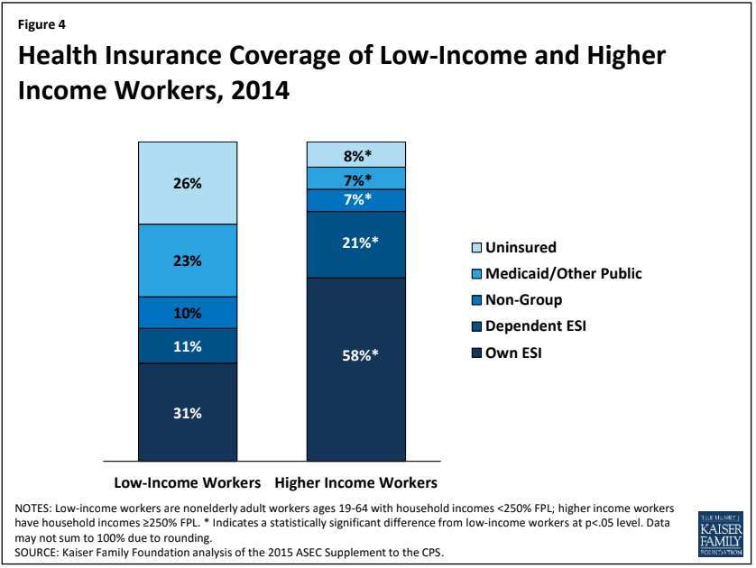

Figure 2: Mean coverage rate for Medicaid and individually purchased insurance by expansion and uninsured rate status

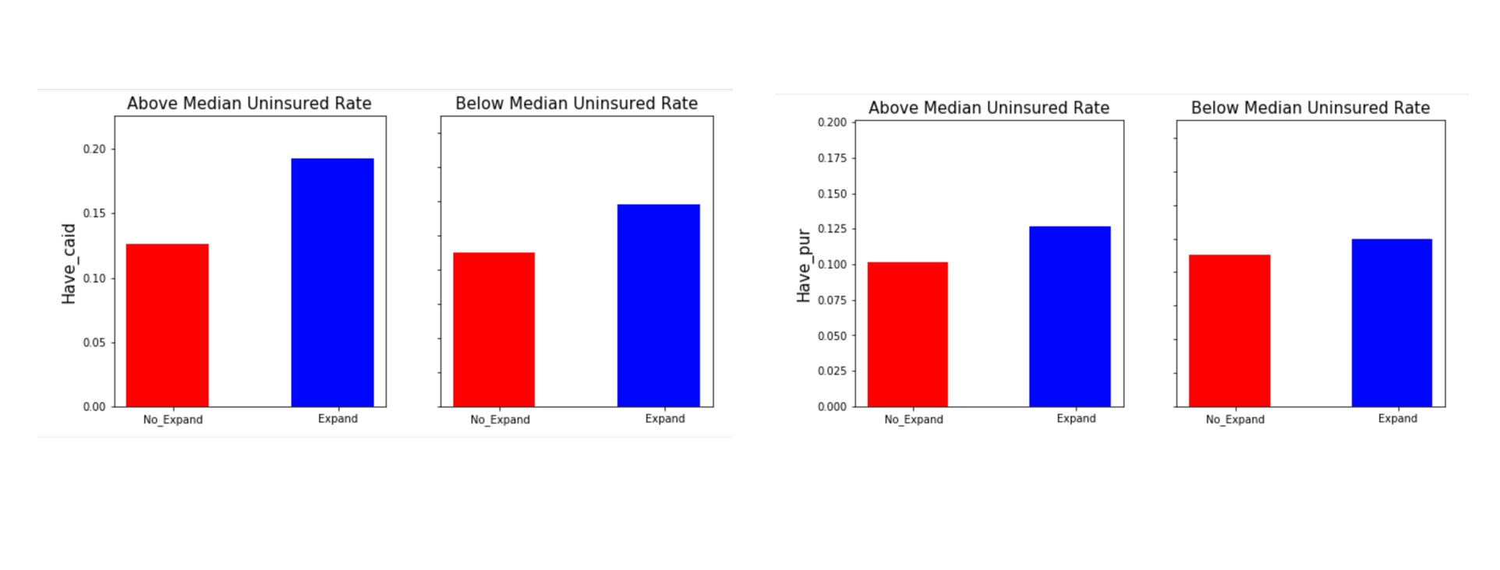

Figure 3: Mean coverage rate for private, employer provided, and any insurance by expansion and uninsured rate status

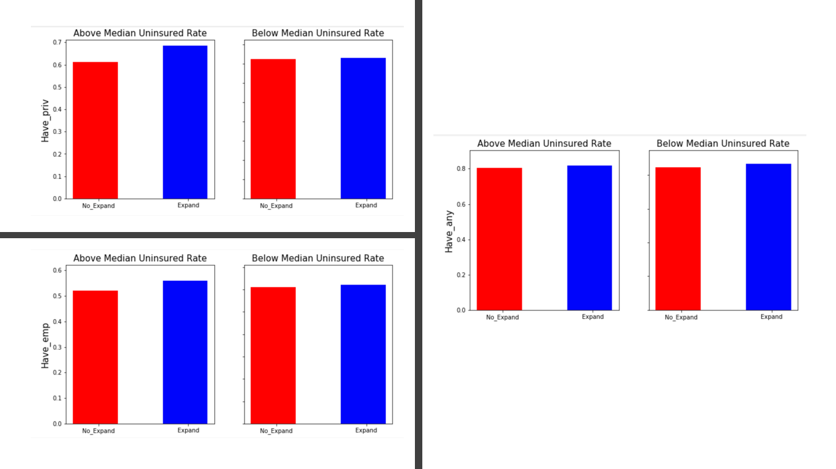

Figure 4: Mean coverage rates by occupation group for expansion and non-expansion states

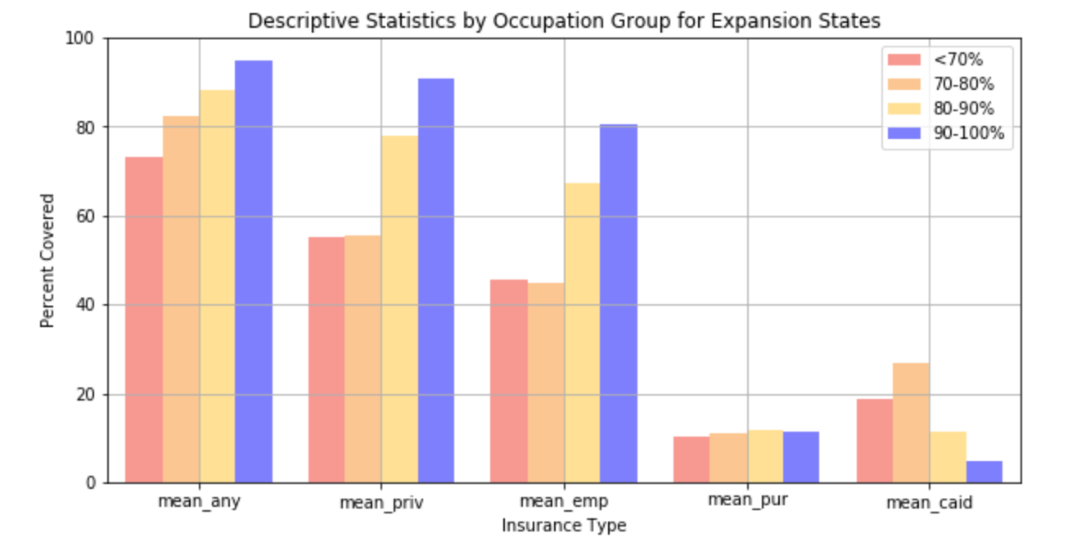

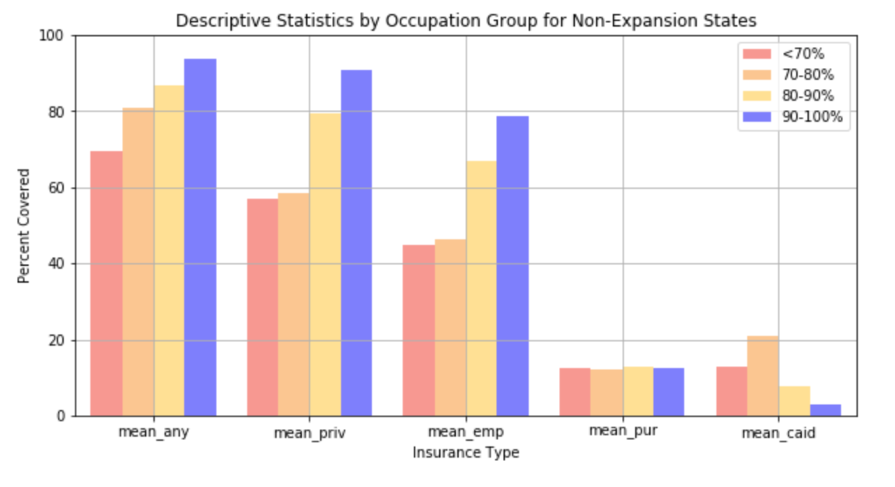

**Figure 5:** Medicaid coverage rates over time for low, middle, and high income populations for expansion (solid line) and non-expansion (dotted line) states. I created the trend lines using ACS data from 2011-2014.



